
KRAMPUS CON 2026
Media & Influencer Press Kit
Krush Brau Park · 4580 W Irlo Bronson Memorial Hwy · Kissimmee, Florida
Every weekend all season · Opens on Krampus Nacht, Saturday, December 5, 2026
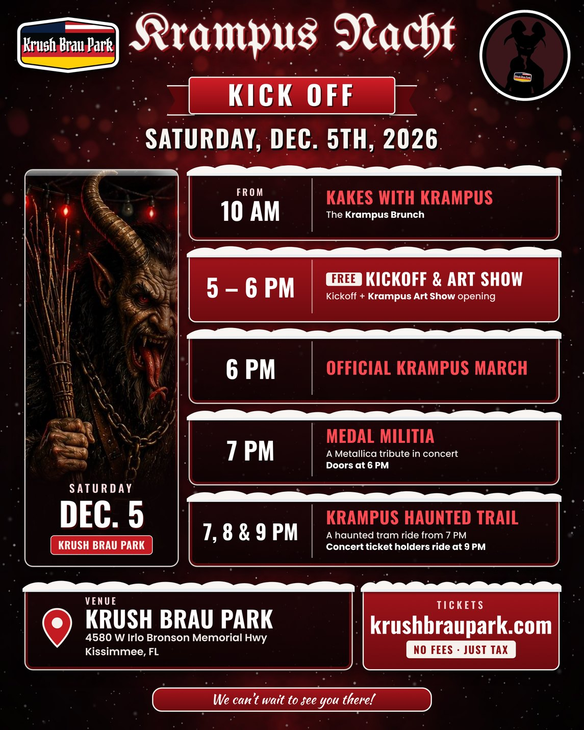
Media contact: Waylon Krush, Founder · contact@krushbraupark.com · (855) 495-7874
Credential requests: contact@krushbraupark.com or https://preview.krampus-us.pages.dev/press/
Prepared October 20, 2026. Prices are the fee-free Square ticket prices (plus 7.5% sales tax) as of October 20, 2026. Items marked [CONFIRM] are not yet confirmed; do not publish them as fact.

Contents
- Overview: Krampus Con 2026
- The park: from closed zoo to Krush Brau Park
- Season at a glance
- Event fact sheets (8): Krampus Nacht kickoff · Krampus Nacht concert · Krampus Art Show · Kocktails with Krampus · Kakes with Krampus · Krush Brau Krampus Haunt · Krampus Escape Room · Krampus Haunted Trail
- Media credential policy and request process
- Suggested coverage priorities for vloggers and short-form creators
- Filming and photography rules [CONFIRM]
- Media assets and past coverage
- Boilerplate
- Contact
- Open items ([CONFIRM] list)

Overview: Krampus Con 2026
Krampus Con is the Dark Christmas season at Krush Brau Park in Kissimmee, Florida. In Alpine folklore, Krampus is the horned companion of St. Nicholas who comes for the naughty on Krampusnacht in early December. At Krush Brau Park, Krampus takes over the park with a march, an art show, Kocktails and Kakes, a haunt, an escape room and a haunted trail through the forest.
Krampus Con runs every weekend all season, like Oktoberfest. It opens on Krampus Nacht, Saturday, December 5, 2026, with a free kickoff (the Krampus March, live music, drinks, vendors and the opening of the Krampus Art Show), followed that night by a ticketed concert from Medal Militia, the veteran-founded salute to Metallica. The other Krampus events then run on multiple dates through the season.
- Opening day: Krampus Nacht, Saturday, December 5, 2026. Kakes with Krampus (Krampus Brunch) from 10am; free Kickoff + Krampus Art Show opening 5 to 6pm; the Official Krampus March at 6pm; Medal Militia concert at 7pm (doors 6pm); Krampus Haunted Trail at 7, 8 and 9pm (concert ticket holders can ride the 9pm trail). Krush Brau Park opens at 10am every Krampus Con Saturday.
- Closing date: December 31, 2026 for Krampus Con, the Krampus Haunt and the Escape Room (New Year's Eve party that night). The Krampus Haunted Trail runs through January 3, 2027.
- Where: Krush Brau Park, 4580 W Irlo Bronson Memorial Hwy, Kissimmee, FL 34746. Events are split between the World Event Center and haunted trail tram station at 4580 W Irlo Bronson Memorial Hwy and the Portal Immersion Center, 2198 Four Winds Blvd, Kissimmee, FL 34746 (same connected property, shared lots).
- Admission: The Krampus Nacht kickoff and the Krampus Art Show are free (reserve a free kickoff ticket on Eventbrite). Every other Krampus Con event has its own ticket on Eventbrite.
- Parking: Free parking on site.
- Public hours: Krush Brau Park is open to the public only during scheduled events. Private parties and events run 7 days a week.
- Krampus Con hours: Park opens 10am on Krampus Con days (Saturdays open with Kakes with Krampus). Closes at midnight Friday and Saturday and 10pm Sunday (Sunday time [CONFIRM]). Krampus appears during Kocktails and Kakes. Closed Christmas Day.
- Web: krampus.us (launching; preview at preview.krampus-us.pages.dev) · krushbrau.com · krushbraupark.com

The park: from closed zoo to Krush Brau Park
In September 2020, U.S. Army veteran Waylon Krush, who was stationed in Bad Aibling, Germany for three years and went to Oktoberfest three times, bought a closed zoo on U.S. 192 with his wife, Kathryn Krush. The site was the former Jungleland Zoo, closed since 2002 and overgrown for years. He had searched Central Florida for a place to hold Oktoberfest year-round, with a garden like the beer garden in Munich, and found it at the zoo.
The property was first named Tiger König ("König" is German for "king"), a play on the zoo's lions and tigers. In October 2020, lawyers for Heineken Asia Pacific, the maker of Tiger Beer, sent a cease-and-desist over the name, and the park became Krush Brau. Today it is a veteran-owned German beer garden and event park next door to Medieval Times on U.S. 192. The original lion and tiger cages from the zoo days still stand at the back of the park, and the animatronic animals on the Krampus Haunted Trail are a nod to the old zoo.
Story angles: a closed zoo turned into a Bavarian beer garden; the Tiger König name and the Heineken letter; the 1997 escape of Nala the lioness from the zoo; a castle next door (Medieval Times).

Season at a glance
Event | Dates | Times | Tickets | Ages | Where
Krampus Nacht kickoff | Sat Dec 5, 2026 | Kakes from 10am; Kickoff + Art Show 5 – 6pm; Krampus March 6pm | Free (reserve on Eventbrite) | All ages | Portal Immersion Center
Krampus Nacht: Medal Militia | Sat Dec 5, 2026 | 7 – 9pm · doors 6pm | $20 + tax (online or at the door) | All ages | World Event Center
Krampus Art Show | Opens Dec 5; runs all season until each piece sells | Opens on Krampus Nacht | Free | All ages | Portal Immersion Center
Kocktails with Krampus | Fri – Sun, Dec 5 – 27 (closed Dec 25) | Fri/Sat 7 – 9:30pm half-hourly; Sun 5, 6, 7pm | $13 – $40 | 21+ | Portal Immersion Center
Kakes with Krampus | Sat & Sun: Dec 5, 6, 12, 13, 19, 20, 26, 27 | Hourly slots from 10am; last slot [CONFIRM] | $5 – $45 | All ages | Portal Immersion Center
Krush Brau Krampus Haunt | Every Krampus Con day (Fri – Sun), Dec 5 – 31; closed Dec 25 | Hourly 10am – 11pm Fri/Sat; 10am – 9pm Sun | $5 – $20 + tax | All ages | Portal Immersion Center
Krampus Escape Room | Every Krampus Con day (Fri – Sun), Dec 5 – 31; closed Dec 25 | Hourly 10am – 11pm Fri/Sat; 10am – 9pm Sun (Haunt listing) | $15 + tax ($20 with the Haunt) or with the trail | All ages | Portal Immersion Center / on the trail
Krampus Haunted Trail | Fri – Sun every week, Dec 5 – Jan 3 (closed Dec 25) | Tours 7, 8 and 9pm | From $10 + tax (separate ticket) | Under 14 with a parent or guardian | Tram station, 4580 W Irlo Bronson

Sources disagree on several dates and times. Each Eventbrite listing is the source of truth for dates, times and prices; the open date conflicts are in the [CONFIRM] list at the end of this kit.
Multi-date events: pick a date and session on Eventbrite. Refund policy: no refunds; tickets and deposits are non-refundable, but guests who can't make it can get a credit toward a future Krush Brau Park event or booking.

Krampus Nacht kickoff
Fact sheet 1 of 8 · Free · All ages · Opening day of Krampus Con
What: The free opening day of Krampus Con: live music, drinks at the bar, Krampus vendors and dark holiday crafts, the Krampus March and the opening of the Krampus Art Show.
When: Saturday, December 5, 2026 (Krampus Nacht). Kakes with Krampus (Krampus Brunch) from 10am; free Kickoff + Krampus Art Show opening 5 to 6pm; the Official Krampus March at 6pm; Medal Militia concert at 7pm (doors 6pm); Krampus Haunted Trail at 7, 8 and 9pm (concert ticket holders can ride the 9pm trail).
Where: Portal Immersion Center, 2198 Four Winds Blvd, Kissimmee, FL 34746 (same connected property, shared lots). Park address: 4580 W Irlo Bronson Memorial Hwy.
Tickets: Free. Reserve a free ticket on Eventbrite so the park can plan for the crowd. Food, drinks and vendor shopping are pay-as-you-go.
Ages: All ages.
Web: krampus.us/events/kickoff/

Coverage highlights
- The Official Krampus March at 6pm, the signature moment of opening day (route [CONFIRM]).
- Opening of the Krampus Art Show and its artists.
- Krampus vendors selling dark holiday art, Krampus merchandise and crafts.
- Same-day double bill: stay for the ticketed Medal Militia concert that night.

Photo and video ops
- Costumed Krampus characters and the Krampus March.
- Vendor stalls and dark holiday crafts.
- The kickoff flyer artwork (supplied as an image).

Media notes
- Kakes with Krampus from 10am; Kickoff + Art Show opening 5 – 6pm; Official Krampus March 6pm; the concert follows at 7pm (doors 6pm); concert ticket holders can ride the 9pm Haunted Trail.
- Media credentials cover the people and events named in the approval.

Krampus Nacht: Medal Militia
Fact sheet 2 of 8 · Concert · Ticketed · All ages
What: The ticketed night show of Krampus Con opening day: Medal Militia, the only veteran-founded salute to Metallica, plays two hours of Metallica spanning more than four decades, from Kill 'Em All and Ride the Lightning through Master of Puppets, the Black Album and today.  When: Saturday, December 5, 2026, 7 to 9pm. Doors at 6pm.  Where: World Event Center, 4580 W Irlo Bronson Memorial Hwy, Kissimmee, FL 34746.  Tickets: $20 plus 7.5% tax online with no ticket fees (krampus.us), on Eventbrite, or at the door.  Band: Medal Militia, veteran-founded Metallica tribute: medalmilitia.com · facebook.com/medalmilitia · instagram.com/medalmilitia_metallica_tribute  Ages: All ages. Full bar and German menu.  Web: krampus.us/events/krampus-nacht-concert/ | 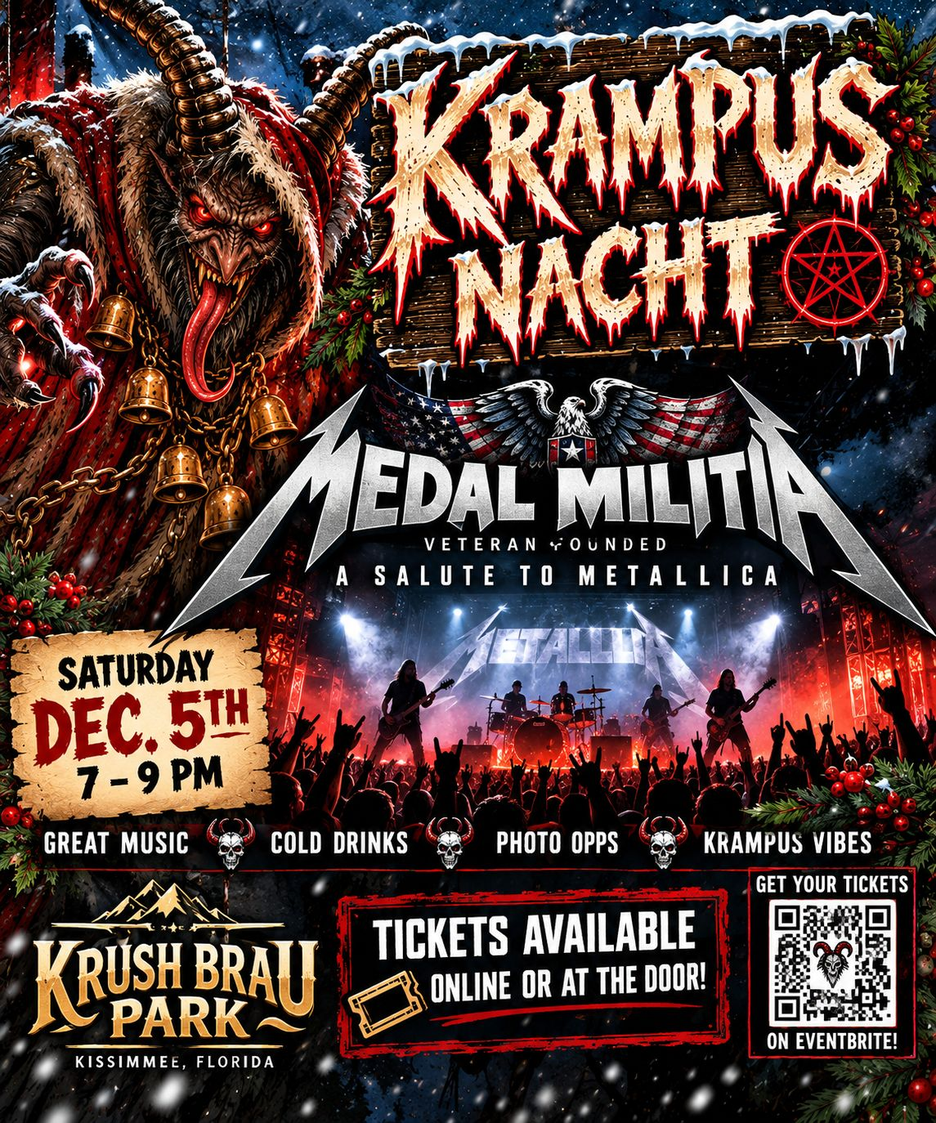

Coverage highlights
- Veteran story: Medal Militia was founded in 2014 by U.S. Navy veterans James O'Brien and Jim Pyle, playing at a veteran-owned park.
- Metallica on Krampus Nacht: the heavy-metal close to opening day.

Photo and video ops
- Crowd and stage shots at the World Event Center.
- The Krampus Nacht concert poster (supplied as an image).

Media notes
- Recording or posting the band's performance needs the band's and park's OK: [CONFIRM].
- Stage, pit or backstage access for media: [CONFIRM].

Krampus Art Show
Fact sheet 3 of 8 · Free · All ages · Curated by Jules
What: Local artists' dark and whimsical interpretations of Alpine Krampus folklore, from dark and macabre to whimsical and fantastical. Every piece is for sale.  When: Opens on the first night, Krampus Nacht, December 5, 2026, and runs all season, at all the Krampus events, until each piece sells or is picked up.  Where: Portal Immersion Center, 2198 Four Winds Blvd, Kissimmee, FL 34746 (same connected property, shared lots).  Tickets: Free. Free with a Krampus Nacht kickoff ticket on opening day.  Curator: Curated by Jules. Primary contact: contact@krushbraupark.com.  Web: krampus.us/art-show/ · open call: krampus.us/artists/ | 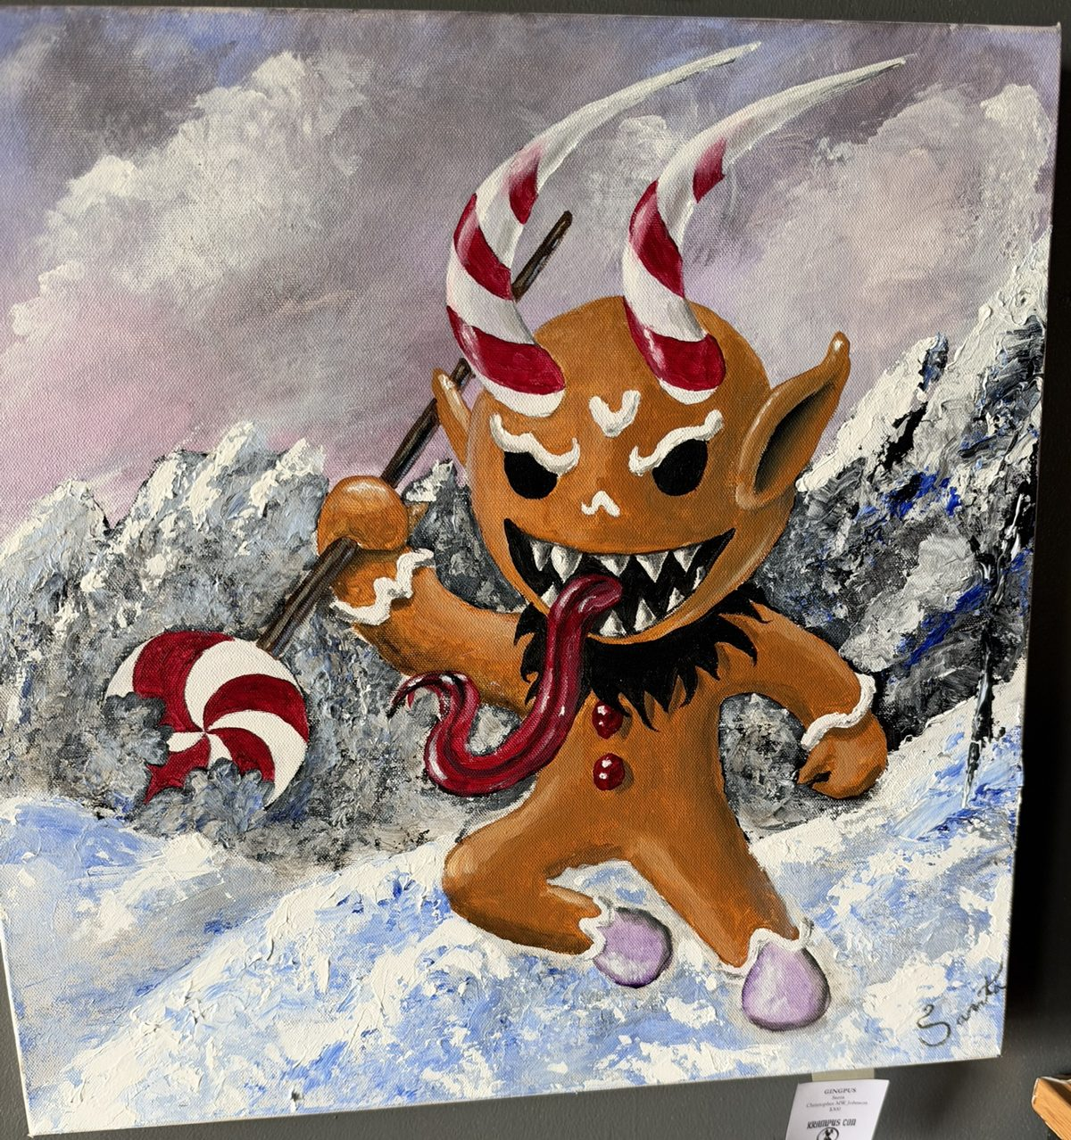

Coverage highlights
- On the wall now (titles and prices as shown on each card): Robert Orlin, "Krampus Under the Red Moon" ($200), "Krampus is Watching" ($300), "They'll be Good" (inquire); Christopher MW Johnson, "Lametta" ($100), "Great Spirit" ($100), "Gingpus" ($300, signed "Santa" as a joke), an untitled carved skull with deer antlers ($1,000); JD Ross, "He sees you when you're sleeping" ($145), "In the Christmas Shadows" (inquire).
- Open call for artists: juried, $10 per artwork up to 5 pieces, 25% gallery commission, artists paid within a week of a sale. Submission deadline [CONFIRM].
- The show stays up until each piece sells, so it changes through the season.

Photo and video ops
- "Gingpus", the evil gingerbread Krampus with candy-cane horns (pictured).
- The antler-skull sculpture on a wooden shield plaque.
- Krampus beside Santa with children (site hero image).

Media notes
- Interviews with Jules or the artists: request through contact@krushbraupark.com.
- Artwork photos are fine for coverage; credit the artist by name [CONFIRM] (usage terms).
- Art show opening reception time [CONFIRM].

Kocktails with Krampus
Fact sheet 4 of 8 · 21+ · Ticketed
What: General admission includes two specialty Kocktails (cocktails or mocktails) and a seat in the outdoor Krampus Lair with Krampus for the duration of the event. More food and drinks inside for purchase. Dress the part: the darker, the better.  When: Fridays, Saturdays and Sundays, December 5 – 27, 2026 (closed Christmas Day). Fri and Sat slots 7:00, 7:30, 8:00, 8:30, 9:00 and 9:30pm; Sun slots 5, 6 and 7pm.  Where: Portal Immersion Center, 2198 Four Winds Blvd, Kissimmee, FL 34746 (same connected property, shared lots).  Tickets: $13 to $40 on Eventbrite. Pick your date and time slot.  Ages: 21+ with valid ID (applies to media and creators too).  Web: krampus.us/events/kocktails-with-krampus/ | 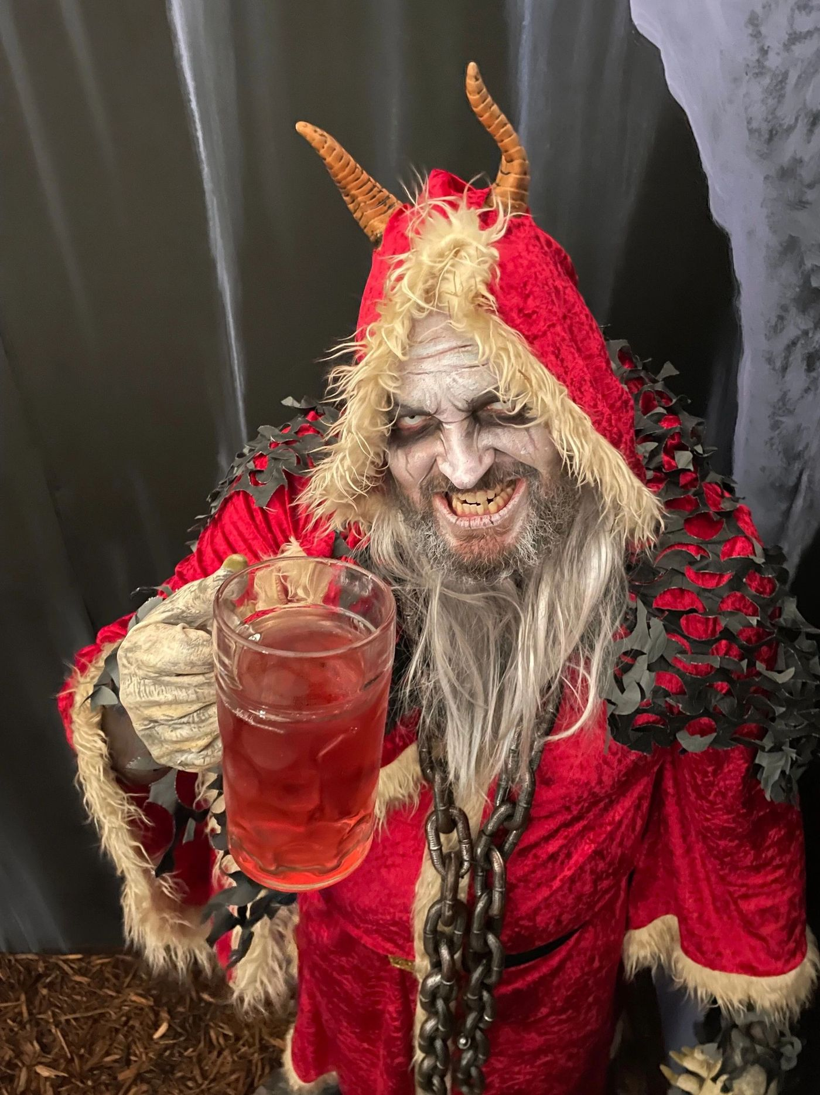

Coverage highlights
- Specialty Kocktails served in the outdoor Krampus Lair.
- Sitting down for a drink with Krampus himself.
- Mocktail option for non-drinkers.

Photo and video ops
- Krampus in a red cloak holding a cocktail (pictured).
- The outdoor Krampus Lair at night.
- Guests in dark holiday dress.

Media notes
- 21+ only, including camera crews.
- Filming other guests drinking: get their consent [CONFIRM] (park policy).

Kakes with Krampus
Fact sheet 5 of 8 · Brunch · All ages · Ticketed
What: A festive pancake brunch and photos with Krampus. Ticket prices (plus 7.5% tax): Spooky Stack (13 & under) $15 (two pan"kakes" with gummies, bacon or sausage); Sinister Stack $10 (two buttermilk pan"kakes"); Haunting Heap $20 (three pan"kakes", bacon, sausage and 2 eggs); Haunting Heap + unlimited mimosa/Bloody Mary (2 hours max) $45; Krampus Mash $16 (bacon, egg and cheese on a toasted pretzel bun with 2 potato pancakes). Coffee, juices, hot chocolate and milk; mimosas and Bloody Marys for adults. À la carte items cost extra.  When: Saturdays and Sundays, December 5, 6, 12, 13, 19, 20, 26 and 27, 2026. Hourly time slots starting at 10am; last slot [CONFIRM].  Where: Portal Immersion Center, 2198 Four Winds Blvd, Kissimmee, FL 34746 (same connected property, shared lots).  Tickets: $5 to $45 on Eventbrite (eventbrite.com/e/krush-brau-kakes-with-krampus-tickets-1991143382457). Choose your date, time and plate.  Ages: All ages. | 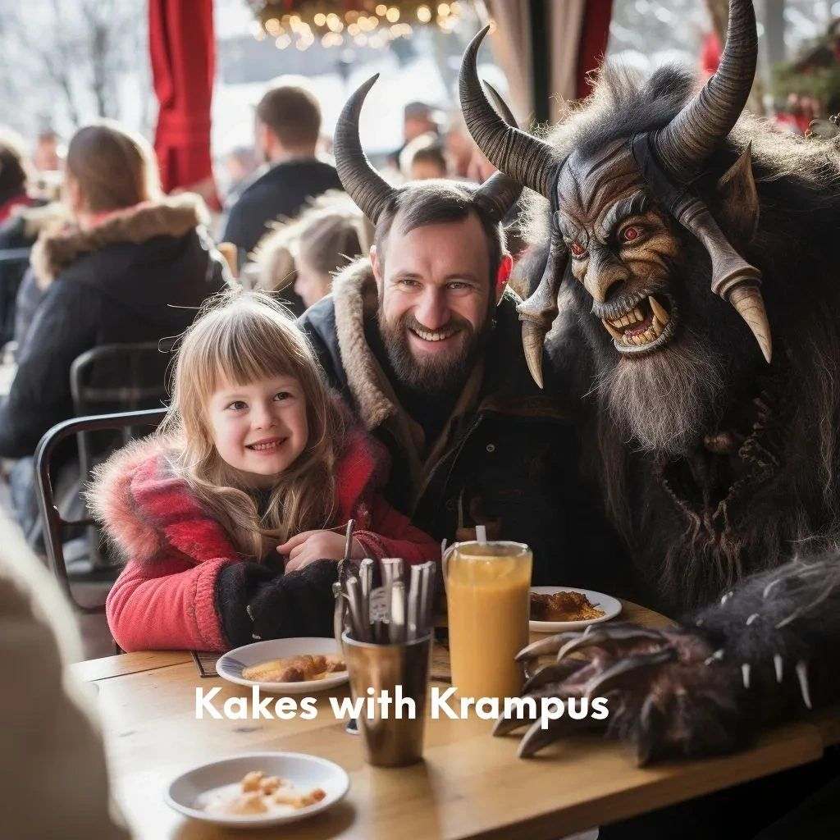

Coverage highlights
- The family-friendly side of Krampus: brunch with the horned beast.
- Themed plates with names like Spooky Stacks and Krampus Mash.

Photo and video ops
- Families eating pancakes with costumed Krampus characters (pictured).
- Photos with Krampus.
- Close-ups of the themed plates.

Media notes
- Families and children attend: no filming identifiable minors without a parent's OK [CONFIRM].

Krush Brau Krampus Haunt
Fact sheet 6 of 8 · Haunted maze · All ages · Ticketed
What: A Krampus-themed haunted maze: a dimly lit labyrinth with eerie light effects and a bone-chilling soundscape, where the undead emerge from the shadows before you confront the horned beast himself. Includes the 40-foot Krampus Container Haunt (skull-covered walls, narrow passages, close-contact scares), which is also part of the Krampus Haunted Trail.  When: Every Krampus Con day (Fri – Sun) from December 5, 2026, hourly from 10am (when Kakes opens): last slot 11pm Fri/Sat, 9pm Sun. Park closes midnight Fri/Sat, 10pm Sun. Closed Christmas Day. Runs through December 31, 2026.  Where: Portal Immersion Center, 2198 Four Winds Blvd, Kissimmee, FL 34746 (same connected property, shared lots).  Tickets: Admission $5, Escape Room $15, Haunt + Escape Room $20 (plus 7.5% tax; no ticket fees at krampus.us, or on Eventbrite).  Ages: All ages. Note: tight spaces, loud sounds and flickering lights. | 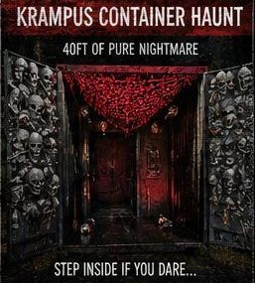

Coverage highlights
- Skull-covered walls and red light inside the 40-foot container.
- Reaction content: close-contact scares.
- The lowest-priced Krampus ticket of the season.

Photo and video ops
- Skull walls under red light (pictured).
- Entry reactions.

Media notes
- Very low light: phone night mode or fast lenses; flash [CONFIRM].
- Filming scare actors and whether you can film inside the maze: [CONFIRM].

Krampus Escape Room
Fact sheet 7 of 8 · Escape room · All ages · Ticketed
What: Inside the 40-foot Haunted Escape Room your group must solve the mystery, break the curse and escape before Krampus returns. Groups welcome.  When: Every Krampus Con day from December 5, 2026: hourly 10am – 11pm Fri/Sat, 10am – 9pm Sun (Haunt listing); trail tours at 7, 8 and 9pm. Closed Christmas Day. Runs through December 31, 2026.  Where: Portal Immersion Center side of the park, and on the Krampus Haunted Trail.  Tickets: Book on its own through the Krush Brau Krampus Haunt listing on Eventbrite (Escape Room $15, or $20 with the Haunt, plus tax), or get it as part of a Krampus Haunted Trail ticket.  Ages: All ages. Tight spaces, loud sounds and flickering lights. | 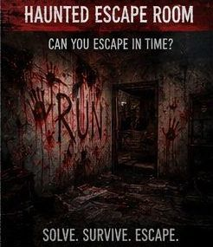

Coverage highlights
- Couple or group against the clock: a strong format for vlogs.
- Also part of the Haunted Trail, so trail coverage can include it.

Photo and video ops
- The Haunted Escape Room poster (pictured).
- Your team solving the mystery.

Media notes
- No-spoiler rule for puzzles and solutions: [CONFIRM].

Krampus Haunted Trail
Fact sheet 8 of 8 · Tram + trail · Separate ticket · Part of Krampus Con
What: During Krampus Con, the Black Forest becomes the hunting ground of Krampus. Guests board the 40-passenger Nightmare Tram on the back road and ride deep into the forest behind Krush Brau Park, past twisted Alpine legends, possessed animatronic animals, abandoned cages, dark rituals, fog, red light, chains and bells. At the trail entrance you continue on foot through nearly one-third of a mile of haunted forest with live scare actors and a Krampus Con finale, including the 40-foot Krampus Container Haunt and the 40-foot Haunted Escape Room.  When: Friday to Sunday nights every week, December 5, 2026 – January 3, 2027, tours at 7, 8 and 9pm. Closed Christmas Day.  Where: Haunted trail tram station, 4580 W Irlo Bronson Memorial Hwy, Kissimmee, FL 34746.  Tickets: Separate ticket on its own Eventbrite listing, $20 adult, $10 accompanied child under 14, $300 private VIP group (plus tax). Not included in the free kickoff ticket. Capacity is limited: reserve a time slot.  Ages: Guests under 14 must be with a parent or legal guardian. | 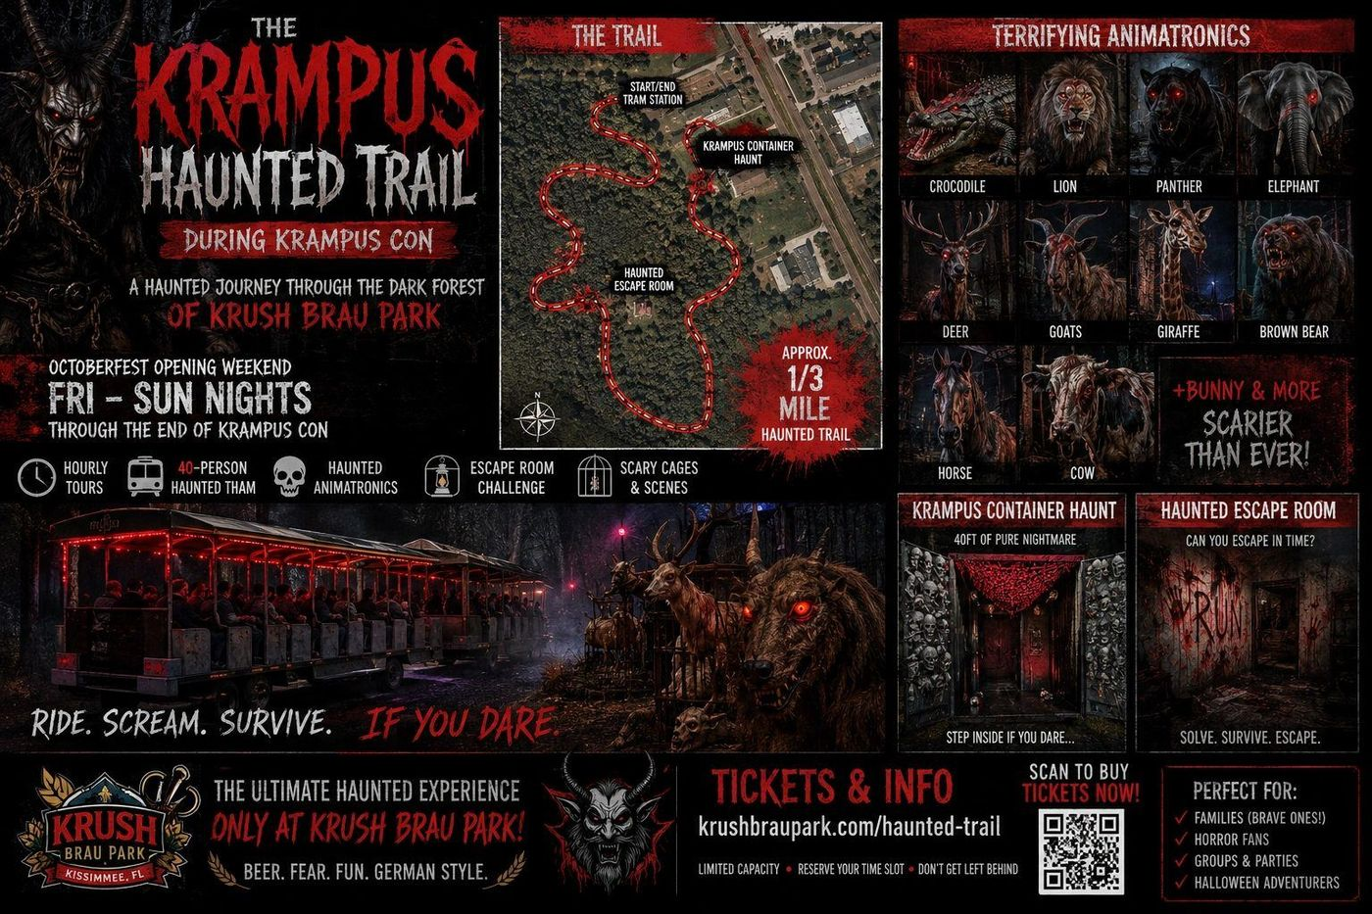

Coverage highlights
- Part of Krampus Con, ticketed separately.
- Animatronic crocodile, lion, panther, elephant, deer, goats, giraffe, bear, horse, cow, bunny and more, at a park built on a former zoo.
- Live scare actors and the Krampus Con finale.

Photo and video ops
- The 40-person tram lit in red.
- Animatronic animals in fog and red light.
- The trail map (supplied as an image).

Media notes
- Tours are timed with limited capacity: media slots [CONFIRM].
- Tripods, gimbals, lights and filming scare actors on the trail: [CONFIRM].
- Dress warm and wear closed-toe shoes.

Media credential policy and request process
Krush Brau Park welcomes journalists, photographers, YouTube and vlog creators, podcasters and short-form creators covering Krampus Con 2026.

How to request
- Send credential requests to contact@krushbraupark.com (subject: "Krampus Con media credential request"), or use the form at https://preview.krampus-us.pages.dev/press/ (krampus.us/press/ at launch).
- Include: your name, outlet or channel name and links, platforms and audience size, the full name of everyone who needs a credential, the number of credentials requested, the events and dates you want to cover, and what you plan to publish and when.
- One request per outlet or creator team.

Policy
- All media credentials and media tickets are subject to approval.
- Krush Brau Park confirms the number of credentials for each outlet or creator team. A request is not approved until you get written confirmation from contact@krushbraupark.com.
- Approved credentials are for the named people, events and dates in the approval email.
- Age rules apply to media: Kocktails with Krampus is 21+ with valid ID; on the Krampus Haunted Trail, guests under 14 must be with a parent or legal guardian.
- Haunted Trail tours are timed with limited capacity; media time slots are assigned in the approval [CONFIRM].
- Request lead time [CONFIRM]. Check-in location and process on arrival [CONFIRM]. Credential form (wristband, badge or Eventbrite ticket) [CONFIRM].
- Please send links to your published coverage to contact@krushbraupark.com.

Suggested coverage priorities for vloggers and short-form creators
Ranked for visual impact and story. All are based on what the park lists for each event.
- Nightmare Tram POV. Board the 40-passenger tram and ride into the forest behind the park. Strong vertical opener.
- The animatronic zoo. Possessed animatronic animals on the Haunted Trail, at a park that used to be a zoo. Pair with the zoo history.
- The Krampus March. The signature moment of Krampus Nacht, December 5.
- Container Haunt reactions. Skull-covered walls, red light and close-contact scares in the 40-foot container.
- Escape-room challenge. Your duo or team against the clock before Krampus returns (spoiler rules [CONFIRM]).
- Kakes with Krampus. Pancakes and photos with Krampus: the family-friendly angle.
- Kocktails in the Krampus Lair. Two specialty drinks and a seat with Krampus (21+).
- The art show. One-of-a-kind Krampus art for sale, curated by Jules; "Gingpus" and the $1,000 antler skull are standouts.
- Medal Militia. Veteran-founded Metallica tribute at a veteran-owned park (recording rules [CONFIRM]).
- The origin story. Closed zoo bought in 2020 to build a year-round Oktoberfest with a Munich-style beer garden; first named Tiger König; next door to Medieval Times.

Short-form hooks
- "We rode a haunted tram into a forest behind an old Florida zoo."
- "This beer garden used to be a zoo called Tiger König. Now Krampus lives here."
- "Pancakes with Krampus: would you?"
- "Can we escape before Krampus comes back?"
Hashtags: #KrampusCon #Krampusnacht #KrushBrauPark #KissimmeeEvents #OrlandoEvents · Tag: @krushbraupark (Instagram, TikTok), @KrushBrauPark (X), Krush Brau Park on Facebook and YouTube.

Filming and photography rules [CONFIRM]
The park has not yet published filming rules for Krampus Con. Everything in this section must be confirmed by Krush Brau Park before it is shared as policy. Until then, credentialed media should ask before planning any of the items below.
Drones | [CONFIRM]
Tripods, monopods, gimbals, external lights | [CONFIRM] (especially on the trail, in the tram and in the container haunt and escape room)
Flash photography | [CONFIRM] (haunt and trail are dark with flickering lights and fog)
Filming scare actors and Krampus characters | [CONFIRM]
Filming other guests and minors; releases | [CONFIRM] (families and children attend Kakes, the kickoff and the trail)
Live-streaming | [CONFIRM]
Recording the Medal Militia set | [CONFIRM] (needs band and park permission)
Escape-room spoilers | [CONFIRM]
Restricted areas (back of house, old zoo cages) | [CONFIRM]
Filming during private events | [CONFIRM]
Commercial use, sponsorships, paid partnerships and disclosure | [CONFIRM]
Music in posted videos | [CONFIRM]

Known conditions: the haunt and trail have tight spaces, loud sounds, fog and flickering lights; trail tours are timed with limited capacity; Kocktails is 21+; guests under 14 on the trail must be with a parent or legal guardian.

Media assets and past coverage
Images available on request or from the krampus.us site (/img/): kickoff flyer, Medal Militia concert poster, Krampus character with cocktail, Kakes with Krampus family photo, Haunted Trail poster, trail map, red-lit tram, container haunt interior, escape room, Krampus Art Show pieces, Krampus Con logo. Open call for artists PDF and social graphics (1080x1080 and 1080x1920). Image credit line [CONFIRM].
- News 6 / ClickOrlando (WKMG), Dec 3, 2025: "Krampus comes to Orlando this week. Where to celebrate this European Christmas tradition" (Krampus Con 2025 with a Krampus March, art show, haunted house and Kakes with Krampus).
- Central Florida Lifestyle, Dec 1, 2025: "Krampus Events Across Central Florida (2025 Guide)".
- Park coverage: Orlando Sentinel (Oct 2, 2022), FOX 35 Orlando "Central Florida Eats" (Feb 23, 2024), Orlando Magazine (May 2022), GrowthSpotter (Sept 22, 2020).

Boilerplate

Krush Brau Park
Krush Brau Park is a veteran-owned German beer garden and event park on U.S. 192 in Kissimmee, Florida. U.S. Army veteran Waylon Krush and his wife, Kathryn Krush, bought the closed Jungleland Zoo in 2020 to build a year-round Oktoberfest with a garden like the beer garden in Munich. First named Tiger König, the park sits next door to Medieval Times and is open to the public during scheduled events, including Oktoberfest and Krampus Con, with private parties and events 7 days a week. Learn more at krushbrau.com.

Krampus Con
Krampus Con is the Dark Christmas season at Krush Brau Park in Kissimmee, Florida. It runs every weekend all season (closed Christmas Day), like Oktoberfest, and opens on Krampus Nacht, December 5, with a free kickoff and the Krampus March. The season includes a Medal Militia concert, the Krampus Art Show, Kocktails and Kakes with Krampus, the Krush Brau Krampus Haunt and escape room, and the Krampus Haunted Trail. Learn more at krampus.us.

Contact
Media contact | Waylon Krush, Founder, Krush Brau Park
Email | contact@krushbraupark.com (media credentials, interviews, art show)
Phone | (855) 495-7874 · 1-855-49-KRUSH
Address | Krush Brau Park, 4580 W Irlo Bronson Memorial Hwy, Kissimmee, FL 34746
Media page | https://preview.krampus-us.pages.dev/press/ (krampus.us/press/ at launch)
Web | krampus.us · krushbrau.com · krushbraupark.com
Social | instagram.com/krushbraupark · tiktok.com/@krushbraupark · facebook.com/KrushBrauPark · x.com/KrushBrauPark · YouTube: Krush Brau Park

Open items ([CONFIRM] list)
Fill these before the kit goes to media. Do not publish any of them as fact.
- Kakes with Krampus last time slot each day (slots run hourly from 10am).
- Sunday closing time: Waylon wrote "9pm on Sunday at 10PM"; kit uses 10pm (confirm).
- Exact weekend dates for each event.
- Krampus March route.
- Art show opening reception time; open call submission deadline and delivery dates; artwork image usage and credit terms.
- Stage, pit or backstage access for media at the concert.
- Media lead time, check-in location, credential form, Haunted Trail media time slots.
- Number of media tickets per request (Waylon confirms each count).
- All filming and photography rules (drones, tripods/gimbals/lights, flash, scare actors, guests and minors, live-streaming, concert recording, escape-room spoilers, restricted areas, private events, paid partnerships, music).
- Image credit line for supplied photos.

